MULTIPLICATION GUIDELINES
Stage One | Stage Two | Stage Three
Multiplication is related to doubling and counting groups of the same size.  3 + 3  Eg use of dominoes and dice.  Counting using a variety of practical resources  Counting in 2s e.g. counting socks, shoes, animal’s legs…  Counting in 5s e.g. counting fingers, fingers in gloves, toes…  Counting in 10s e.g. fingers, toes…  Pictures / marks  There are 3 sweets in one bag.  How many sweets are there in 5 bags?  The above is required before moving on to Stage 2. | x = signs and missing numbers  7 x 2 = = 2 x 7  7 x = 14 14 = x 7  x 2 = 14 14 = 2 x  x ∇ = 14 14 = x ∇  Arrays and repeated addition  Looking at rows  3 + 3  2 groups of 3  - 4 x 2 or 4 + 4  Inverse 2 x 4 or 2 + 2 + 2 + 2 (children need to understand what the 2 represents)  If the calculation is 7 x 5 for example, children should understand that this means 7 + 7 + 7 + 7 + 7  However, children with secure knowledge of inverse and arrays can use the commutative to count 7 lots of 5.  Doubling multiples of 5 up to 50  15 x 2 = 30  Partition  Children need to be secure with partitioning numbers into 10s and 1s and partitioning in different ways: 6 = 5 + 1 so  e.g. Double 6 is the same as double five add double one.  AND double 15  10 + 5  20 + 10 = 30  At the end of Stage 2 the children should use the above strategies, as well as knowing the 2, 5 and 10 times tables from memory. | x = signs and missing numbers  Continue using a range of equations as in Stage 2 but with appropriate numbers.  Arrays and repeated addition  Continue to understand multiplication as repeated addition and continue to use arrays and number lines (as in Stage 2).  Doubling multiples of 5 up to 50  35 x 2 = 70  Partition  - Moving onto:  1 6 x 1 7 = 272  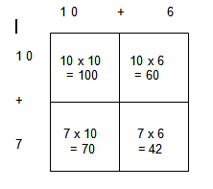  Use known facts and place value to carry out simple multiplications  Use the same method as above (partitioning), e.g.  32 x 3 = 96  = 96  At the end of Stage 3 the children should know their 2,4,5,6 and 10 times tables.  They should also use practical and informal written methods such as number lines to multiply TU X U.

MULTIPLICATION GUIDELINES
Stage Four | Stage Five | Stage Six
x = signs and missing numbers  Continue using a range of equations as in Stage 3 but with appropriate numbers  Partition  Continue to use arrays:  18 x 9 = 162  18 x 9 = (10 x 9) + (8 x 9) = 162  Use Multiarray ITP to model partitioning into tens and ones, using the familiar visual pattern of 5s.  OR  Use the grid method of multiplication (as below)  Pencil and paper procedures  100 + 70 + 60 + 42  170 + 102 = 272 | Partition  47 x 6 = 282  47 x 6 = (40 x 6) + (7 x 6) = 282  OR  Use the grid method of multiplication (as below)  Pencil and paper procedures  Grid method  72 x 38 is approximately 70 x 40 = 2800  REMEMBER, ALWAYS PRESENT CALCULATIONS HORIZONTALLY IN ORDER TO CONSIDER MENTAL CALCULATIONS FIRST.  Again, if the calculation should be possible mentally then do not give it to practise vertical calculation, e.g. 23 x 15 should not be calculated vertically. Consider use of numbers carefully. Avoid numbers which involve x 2, x 4, x 5, x 8.  70 + 2  2100 + 560+ 60 + 16  2660 + 76 = 2736  It is important to write the calculation in the grid for both the pupil and teacher to be able to identify errors made in multiplication facts or in the calculating the process.  It is also a reminder that the area of the rectangle is being calculated and the system is clear.  Where possible, use mental calculation strategies to calculate the total e.g. looking for known facts or adding the largest number first.  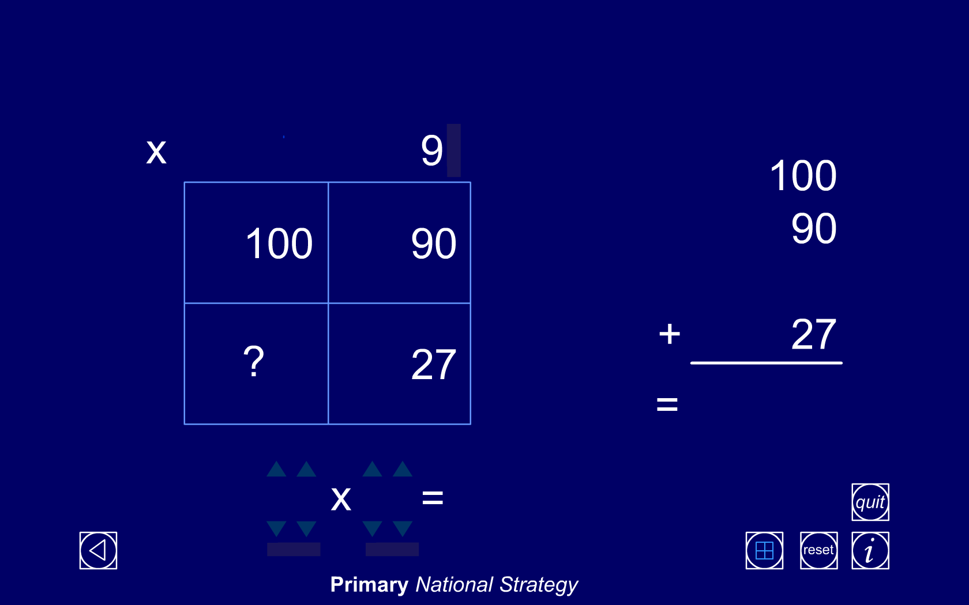  Use Multiplication grid ITP to assess understanding and application of the grid method by ‘hiding’ the question parts and ‘revealing’ some of the answer parts.  Expanded Column Multiplication  Children should describe what they do by referring to the actual values of the digits in the columns. For example, the first step in 38 × 7 is ‘thirty multiplied by seven’, not ‘three times seven’, although the relationship 3 × 7 should be stressed.  30 + 8 38  x 7 x 7  56 (8 x 7 = 56) 56  210 (30 x 7 = 210) 210  266 266 | Partition  87 x 6 = 522  87 x 6 = (80 x 6) + (7 x 6) = 522  OR  Use the grid method of multiplication (as below)  Pencil and paper procedures  Grid method  372 x 24 is approximately 400 x 20 = 8000  Extend to decimals with up to two decimal places.  Short Column Multiplication  The recording is reduced further, with carry digits recorded below the line.  38  x 7  266  5  Children who are already secure with multiplication for TU × U and TU × TU should have little difficulty in using the same method for HTU × TU or applying decimals.  286  x 29  2574 (9 x 286 = 2574)  5720 (20 x 286 = 5720)  8294  1  EXPANDED LONG MULTIPLICATION  1 6 X 1 7  1 6  X 1 7  1 0 0 10 X 10  6 0 10 X 6  7 0 7 X 10  4 2 7 X 6  2 7 2  Initially, teach alongside the multiplication grid and show how each calculation links to each ‘box’ of the multiplication grid.  Tip: If TU x TU (i.e. 2-digit x 2-digit) then a ‘2 x 2’ multiplication needs 4 calculations/ boxes (2 x 2 = 4). If HTU x TU (3-digit x 2-digit) then a ‘3 x 2’ multiplication needs 6 calculations (3 x 2 = 6) etc.  Check that the correct calculations have been made by looking for the numbers involved (on the right) i.e. 10 x 16 (the first two) and 7 x 16 (the second two).  Where possible, use mental calculation strategies to calculate the total e.g. looking for known facts or adding the largest number first.  This can be moved onto a more efficient recording, using greater mental calculation skills and strategies:  1 6 x 1 7  1 6  X 1 7  1 6 0 10 X 16  1 1 2 7 X 16 (mentally calculating 7 x  10 plus 7 x 6 as 70 + 42)  2 7 2
  30  +  8  70 x 30  = 2100 | 30 x 2  = 60
  70 x 8  = 560 | 8 x 2  =16

Progression in Calculating from the Renewed Framework
End of Year Objectives

Stage 1 – practical problems that combine groups of 2, 5 or 10
Stage 2 - represent multiplication as repeated + and arrays. Practical and informal written methods and vocabulary used to support multiplication.
Stage 3 – Describe the effect of Ux10, TUx10, Ux100, TUx100. Practical and informal written methods for TuxU. Understand and use ‘3 for free’ for x and ÷ of the 2,3,4,5,6 and 10 times-tables.
Stage 4 – Derive and recall x facts up to 10x10 and ‘3 for free’ facts. Multiply numbers to 1000 by 10 and 100. Written methods and explain TuxU.
Stage 5 – mentally multiply TUxU and mentally x25. Multiply whole numbers and decimals by 10, 100 and 1000. Written methods to multiply HTUxU, TUxTU, U.txU
Stage 6 – mentally calculate TUxU, U.tXU. Written methods to TUxTU, HTUxTU

As with addition and subtraction, before progressing through the stages of calculation:

Learning
- It is crucial to know or be able to derive key number facts –
Understand and use doubling and halving
×/÷ 10 (as moving a place to the left/right NOT “add a zero” etc!!)

- Place value and partitioning MUST be clearly understood and explained using the appropriate mathematical vocabulary.

Teaching
- The number line and the use of arrays must be modelled as images to support calculation from Reception to Year 6.

- Jottings must be modelled as a clear image/strategy for mental calculation.
If the calculation should be possible mentally then do not give it to practise vertical calculation, e.g. 23 x 15 should not be calculated vertically. Consider use of numbers carefully.
- Always present calculations horizontally in order to consider mental calculations first.

Always think:
- Can I do it mentally?
- Can I do it with a jotting?
- Do I need a written method (vertical layout)?
- Do I need a calculator?
MENTAL STRATEGIES
Learning times-tables, while making calculating more efficient, is not essential for EVERY child as not ALL children will be able to learn ALL multiplication facts. However, strategies to calculate the facts not yet recalled ARE essential:
× 2 double ÷ 2 halve
× 4 double-double ÷ 4 half and half again
× 8 double-double-double ÷ 8 half, half and half again
Model jottings for halving and doubling and use known facts and place value
½ of 6 4
“Half of 6 tens or half of 60 is 3 tens or 30”
“Half of 4 is 2.”
½ ½

30 + 2
Where the number of tens (or hundreds) is odd and the fact unknown, use known facts to derive the new fact:
e.g. ½ of 7 6
× 5 ½ of × 10
× 50 ½ of × 100
× 25 ¼ of × 100 (or ½ and ½ again of × 100
× 12 × 10 plus × 2 (double)
× 15 × 10 plus ½ of × 10

½

(60 + 10)

½ ½

30 + 5 + 3

