

Special Educational Needs and Disabilities (SEND) Information Report 2024–2025

- Vision and Ethos

“We act in the best ways we can; to support each child become the best version of themselves.”

“We selflessly act in the best interests of our children and families, fostering a culture of community and belonging centred on a complete understanding of our children and our families. We will ensure all children establish a strong, courageous sense of self, so that they become responsible, global citizens for the future. We will be a safe haven for our children; with each child becoming the best version of themselves, prepared for an active and positive role in society.”

This vision encompasses the holistic development of children, equipping them with skills for life, and preparing them for a rapidly changing world. This vision also empowers staff, crucial for fostering a positive school culture. In the 21st century, collaboration is paramount. Visionary Leadership will foster a collaborative environment among teachers, students, parents, and the community. Working together creates a sense of ownership and shared responsibility for the school’s success.

A clear vision, understood by the school’s community, sets the road map to develop the courage, integrity and kindness needed to ensure we act in the interests of our children and their families, through sincere, honest Professional Love.

Our vison will be most effective when it is both intuitively delivered and internalised by all.
At the heart of our provision is a deeply held commitment to inclusion, equity, dignity and excellence for every child and family. Children flourish within a happy, nurturing and highly inclusive environment where they are supported to become the very best version of themselves. Staff know children and families exceptionally well and maintain consistently high expectations for all learners, including those with SEND. Our work is underpinned by the principles of professional love, justice as fairness and greatness of soul.
We believe that all children, regardless of need, disability, language, social background or circumstance, deserve access to exceptional early education, therapeutic support and opportunities to flourish. Our provision has been developed in direct response to the needs of the local community and the increasing complexity of children’s social, emotional, communication and developmental needs following the COVID-19 pandemic. Leaders recognise that inequalities in health, housing, language access and social opportunity can profoundly affect children’s development and family wellbeing. As a result, the provision is not deficit-focused; instead, it builds capacity within children, families, staff and the wider community.
The school works in close partnership with families, health professionals, local authority services, NHS North East London Integrated Care Board (ICB), community organisations and specialist practitioners to ensure that children with SEND receive highly personalised, ambitious and effective support from the earliest possible stage.
Leaders remain committed to:
- Creating an inclusive environment where all children feel safe, valued and successful.
- Identifying SEND needs early and responding swiftly.
- Delivering evidence-informed interventions.
- Ensuring every child experience high-quality relationships and communication.
- Supporting families through compassionate partnership working.
- Developing staff expertise through continuous professional development.
- Removing barriers to participation, learning and belonging.
- Improving long-term outcomes for children and families.

- Leadership, Governance and Strategic Oversight
Leaders maintain exceptionally high aspirations for children and young people with SEND and have established a culture where inclusion, belonging and ambition are deeply embedded across all aspects of provision.
SEND leadership is strategic, reflective and highly collaborative. Governors maintain rigorous oversight of SEND effectiveness through review processes, evaluation of outcomes and strategic challenge. The SEND policy and Inclusion Strategy are currently being revised to ensure full compliance with statutory guidance and to reflect recent developments within national SEND reform. Once finalised, these will be ratified by governors and published alongside linked safeguarding, curriculum and inclusion policies.
- How Leaders Ensure Children and Young People with SEND Thrive
Leaders maintain exceptionally high aspirations for children and young people with SEND and have established a culture where inclusion, belonging and ambition are deeply embedded across all aspects of provision.
The school ensures that:
- The SEND policy is current, responsive and aligned with statutory guidance. The revised policy is being finalised, will be ratified by governors and published on the school website alongside linked safeguarding, curriculum and inclusion policies.
- The curriculum is carefully designed to meet the needs of all pupils, particularly those with SEND.
- There is a clear identification strategy with robust systems for assessment, monitoring and intervention.
- The SEND strategy reflects the Local Offer and is tailored to individual pupil needs.
- The participation, engagement and wider involvement of pupils with SEND is routinely monitored, reviewed and evaluated.
- Quality First Teaching and the graduated approach are monitored carefully through leadership review, pupil progress meetings and SEND quality assurance.
- SEND interventions are evidence-informed, highly targeted and demonstrably effective.
- Pupil voice and family voice are integral to strategic planning and curriculum development.
As part of the PINS process the school inclusion audits were conducted by occupational therapists and speech and language professionals and recommendations were implemented. Emerging questions from learning walks, discussions with leaders, pupil voice, work scrutiny and documentary evidence continue to shape future SEND development priorities
Leaders ensure that:
- The curriculum is carefully designed to meet the needs of all pupils, particularly those with SEND.
- Identification systems are robust, responsive and well understood by staff.
- Quality First Teaching and the graduated approach are monitored through leadership review, pupil progress meetings and SEND quality assurance.
- Interventions are evidence-informed, highly targeted and evaluated carefully.
- Pupil and family voice contribute meaningfully to strategic planning and curriculum development.
- Provision aligns closely with the Local Offer and reflects individual pupil need.
Leaders work closely with:
- Speech and Language Therapists.
- Occupational Therapists.
- Educational Psychologists.
- Educational Wellbeing Teams.
- NHS partners.
- SEND specialist practitioners.
- Local authority services.
- Parent support organisations.
- Community and family support networks.
The impact of SEND provision is reviewed through:
- Child progress data.
- Attendance.
- Emotional wellbeing measures.
- Family engagement.
- Professional supervision.
- Multi-agency review.
- Comparative local and national data.
- Value-for-money analysis.
Learning walks, pupil voice, work scrutiny and documentary evidence continue to shape future SEND priorities and improvement planning.
- Overview of SEND Development and Impact
Over the past academic year, the school has undertaken substantial work to strengthen SEND provision and ensure that all children and young people with SEND thrive.
This has included:
- Participation in the Partnerships for Inclusion of Neurodiversity in Schools (PINS) project.
- Reviewing and redrafting the SEND policy.
- Refining curriculum design.
- Strengthening identification systems.
- Expanding targeted interventions.
- Increasing collaboration with external professionals.
- Embedding more inclusive and therapeutic approaches.
- Developing stronger partnerships with families and parent groups.
This work reflects the school’s unwavering commitment to ensuring equitable access to education, support and opportunity for all pupils.

Outcomes demonstrate substantial improvement over a three-year period:
- Reading outcomes improved by 42.9%.
- Writing outcomes improved by 57%.
- Pupils with EHCPs achieved outcomes above both local authority and national comparative data.
- Attendance improved from 73.8% to 91.1% through targeted family support and relational practice.
- Children receiving SEND interventions consistently achieved outcomes above local and national comparative measures.
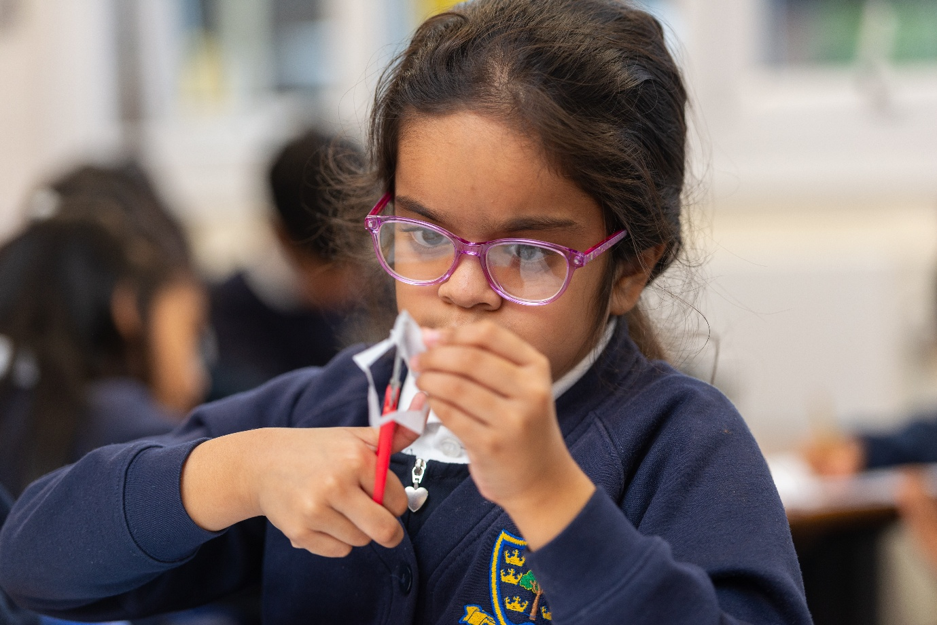

- Identification and Assessment of SEND
The school has established a clear and structured approach to identifying pupils with additional needs through the graduated approach outlined in the SEND Code of Practice.
Children’s needs are identified through:
- Observations and developmental tracking.
- Baseline assessments.
- Speech and language screening.
- Progress reviews.
- Wellbeing and emotional development monitoring.
- Family voice and parental discussion.
- Multi-agency assessment.
- Early Help and safeguarding processes where appropriate.

A Record of Concern (ROC) system has been introduced to:
- Standardise identification procedures.
- Strengthen staff accountability.
- Support early intervention.
- Ensure Quality First Teaching strategies are implemented before formal intervention.
Targeted professional development has improved staff confidence in recognising SEND, particularly social, emotional and mental health needs.
The setting demonstrates particular strength in:
- Early identification within Early Years.
- Swift referral processes.
- Multi-agency collaboration.
- Timely intervention.
Children requiring additional support receive individualised planning and targeted intervention through the graduated approach:
- Assess
- Plan
- Do
- Review
Families are fully involved at every stage of planning, review and decision-making.
The school has established a clear and structured approach to identifying pupils with additional needs through the graduated approach outlined in the SEND Code of Practice.
As a result:
- The number of pupils with Education, Health and Care Plans (EHCPs) has increased by 32%.
- The number of pupils receiving SEND Support has increased by 59%.
This reflects significantly improved identification systems and earlier recognition of need.
The school demonstrates particular strength in:
- Early identification within Early Years.
- Swift referral processes.
- Multi-agency collaboration.
- Timely intervention.
These increases reflect improved identification and earlier recognition of need rather than increased exclusion from universal provision.

- Curriculum, Teaching and Inclusive Practice
The curriculum has been carefully designed to ensure accessibility, ambition and inclusion for all learners. Across the provision, inclusion is embedded within everyday practice.
Recent curriculum developments, particularly within English, have significantly strengthened inclusive practice through:
- Increased opportunities for processing stories and language.
- Greater use of discussion, drama and oral rehearsal.
- Rich visual and sensory stimuli.
- Structured opportunities for expressive communication.
- Flexible and adaptive teaching approaches.
The school draws upon approaches from the Centre for Literacy in Primary Education (CLPE) to strengthen:
- Language development.
- Communication skills.
- Social understanding.
- Creative expression.
- Talk-based pedagogy.
- Access to high-quality literature.
These approaches particularly support pupils with:
- Speech and language needs.
- Communication difficulties.
- Cognition and learning needs.
- Social interaction difficulties.
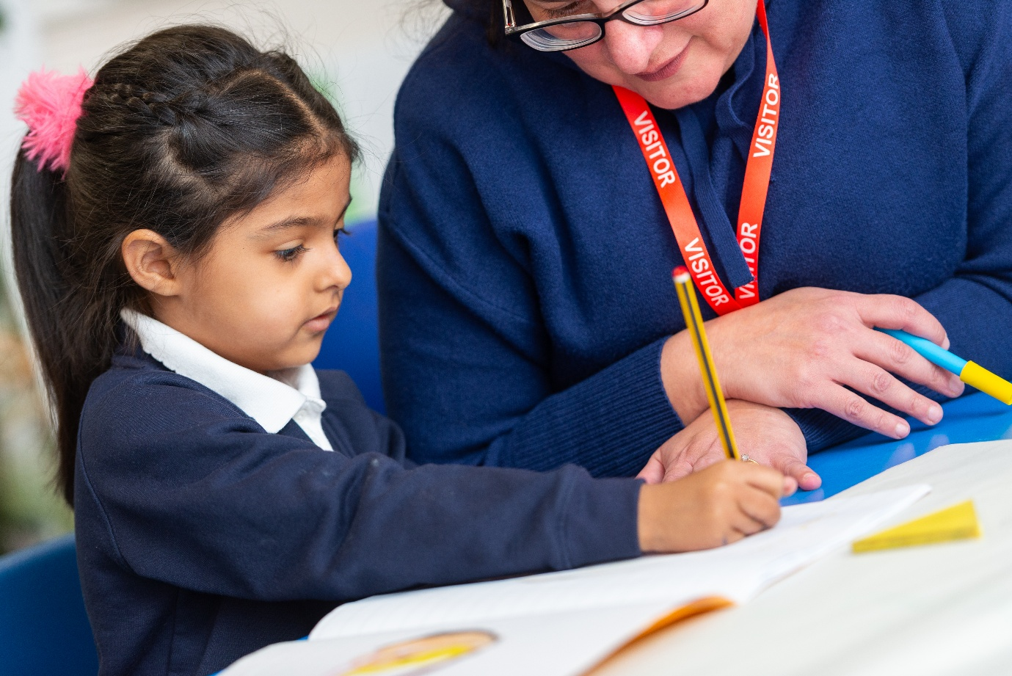
Teachers adapt learning carefully to ensure all pupils can access ambitious curriculum content and experience success. Pupils working below age-related expectations receive highly scaffolded support, while small-group and one-to-one teaching maximise engagement and accessibility.
Across the wider curriculum, pupils learn exceptionally well because learning is carefully sequenced, adapted and delivered with expertise. Staff continuously check understanding through skilled questioning and responsive teaching. Misconceptions are identified quickly and addressed effectively.
From Nursery onwards there is a sharp focus on communication and language development. Children benefit from language-rich environments where they learn new vocabulary and develop confidence in expressing their needs, ideas and emotions.
Practitioners consistently:
- Use communication-rich approaches.
- Model language effectively.
- Adapt interactions to developmental need.
- Provide nurturing and emotionally available relationships.
- Deliver trauma-informed practice.
- Use emotional coaching and PACE-informed approaches.
- Create highly enabling environments.
- Promote belonging, identity and cultural inclusion.
- Use play-based pedagogy to support learning.
Children benefit from:
- Visual communication aids.
- Sensory-informed environments.
- Therapeutic play.
- Emotional literacy support.
- Outdoor and nature-based learning.
- Structured language programmes.
- Small-group intervention.
- Relationship-based approaches.
Professional development is prioritised to ensure consistently high standards of inclusive practice.

- Individualised Support and SEND Provision
Every child receiving SEND support has an Individualised Education Plan (IEP) which includes:
- Individual targets.
- Graduated support strategies.
- Clear intervention planning.
- Parent consultation.
- Termly review.
Parents are offered dedicated SEND meetings annually in addition to standard parent consultations. The SEND team quality assures all IEPs to ensure consistency, ambition, clarity and precision.

Pupil progress meetings review:
- Academic progress.
- Emotional wellbeing.
- Attendance.
- Engagement.
- Intervention impact.
This ensures that concerns are identified rapidly and support is adapted accordingly.
The school provides an extensive range of targeted interventions and specialist support, including:
- Speech and Language Therapy (SALT).
- Occupational Therapy (OT).
- Colourful Semantics.
- Attention Autism.
- Maths intervention groups.
- Sensory circuits.
- TacPac.
- Communication groups.
- LEGO-based Therapy.
- Emotional regulation interventions.
- RAW programmes.
- Therapeutic wellbeing interventions.
The school actively participates in the Partnerships for Inclusion of Neurodiversity in Schools (PINS) Project.
This work has strengthened collaboration between:
- Parents and carers.
- Occupational Therapists.
- Educational Psychologists.
- Speech and Language Therapists.
- School leaders.
- Teaching staff.
Parent and pupil voice surveys have informed ongoing developments in SEND provision.
The school has also:
- Undertaken external OT and SALT audits.
- Worked closely with Educational Psychologists to strengthen SEMH understanding.
- Collaborated with SEND Assessment and Treatment Services (SENDATS).
- Developed partnerships with the ETP Parent Support Group.
- Become a designated Mental Health Support Team school.
Through these partnerships the school provides:
- Parent workshops.
- Mental health support.
- Family groups.
- Staff training.
- Therapeutic guidance.
- Holistic intervention planning.
This breadth of provision demonstrates a deeply embedded commitment to inclusive, responsive and relational practice.

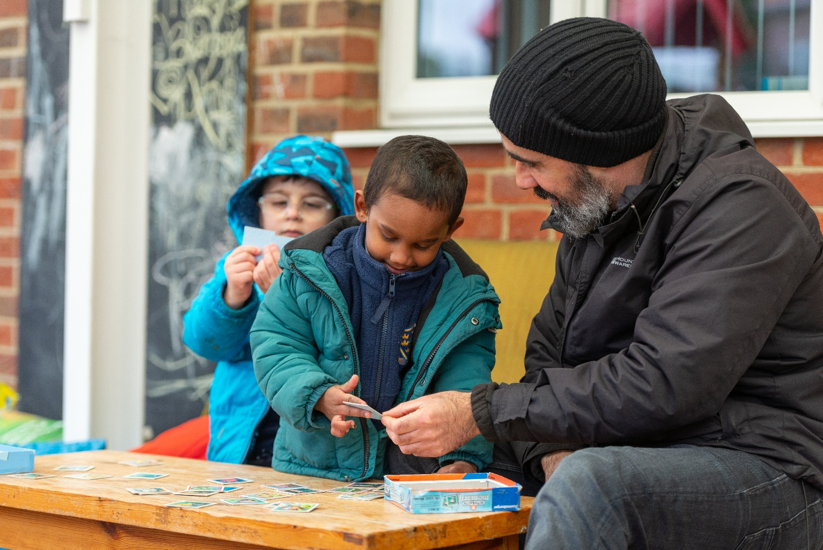

- Speech, Language and Communication
Communication and language development are central priorities across the provision.
Children benefit from:
- Weekly Speech and Language Therapy support.
- ELKLAN-trained practitioners.
- Nuffield Early Language Intervention (NELI).
- Small-group communication interventions.
- Language-rich learning environments.
- Integrated therapeutic approaches.
- Family speech and language workshops.
Specialist therapists work directly within the setting alongside practitioners to ensure strategies are embedded consistently into everyday provision.
The NELI programme has been particularly effective in supporting children with speech and language delay, including children with English as an Additional Language and newly arrived families.
Children receiving targeted communication support achieved outcomes significantly above local and national comparative figures in Communication and Language.
The NELI programme has been particularly effective in supporting children with speech and language delay, including children with English as an Additional Language and newly arrived families.
The Family Speech and Language Hub provides:
- Weekly guidance for families.
- Play-based communication strategies.
- Access to specialist professionals.
- Peer support opportunities.
- Emotional wellbeing support.
Families report increased confidence, reduced isolation and stronger understanding of how to support their child’s communication development.

- Therapeutic, Mental Health and Neurodiversity Support
The setting recognises the increasing social, emotional and mental health needs of children and families and provides a wide range of therapeutic support. The school works closely with the local authority special education advisor for social, emotional and mental health and from Redbridge Mental Health Support Team (MHST).
Children and families can access:
- Play therapy.
- Counselling.
- Emotional literacy support.
- Trauma-informed interventions.
- PACE-informed approaches.
- LEGO-based Therapy.
- Music and rhythm-based wellbeing interventions.
- Family wellbeing programmes.
- Support from the Redbridge Mental Health Support Team (MHST)
Therapeutic provision focuses on:
- Emotional regulation.
- Safety and trust.
- Communication.
- Relationship building.
- Self-esteem.
- Resilience.
- Family wellbeing.
The RAW Project (Rhythm and Wellbeing) supports emotional wellbeing through music, creativity, rhythm and co-regulation. Monitoring demonstrates that all identified children made expected progress in targeted personal, social and emotional development outcomes.
The school demonstrates a strong commitment to neurodiversity-affirming practice. Provision includes:
- ADHD parent support through ADDUP+.
- Participation in the PINS project.
- Sensory-informed environments.
- Communication adaptations.
- Emotional regulation support.
- Family guidance
- Staff training.
Leaders work proactively to:
- Improve understanding of neurodivergence.
- Strengthen parent partnerships.
- Build inclusive environments.
- Improve staff confidence.
- Reduce barriers to participation.
- Promote belonging and self-worth.
Parent workshops, information sharing and peer support opportunities empower families and strengthen home-school collaboration.

- Family Partnership and Co-production
Families are viewed as equal partners. Strong relationships between staff and families are a defining strength of the provision.
The setting provides:
- Family Networks and Coffee Mornings.
- Stay and Play sessions.
- Parent workshops.
- SEND guidance and advocacy.
- Emotional support.
- Multi-agency signposting.
- Parent voice opportunities.
- Secure Base Model support.
- Partnerships for Inclusion of Neurodiversity in Schools (PINS)
The Secure Base Model is embedded throughout family engagement work to reduce anxiety, strengthen trust and improve children’s emotional security.
This work has contributed significantly to improved attendance, family engagement and children’s personal, social and emotional development.
Families consistently report:
- Increased confidence.
- Reduced isolation.
- Improved understanding of SEND.
- Greater emotional wellbeing.
- Increased ability to support their child.
- Stronger trust in professionals.
Parent and pupil voice surveys continue to inform ongoing SEND development.
The school achieved the highest parental satisfaction rating within the PINS project.
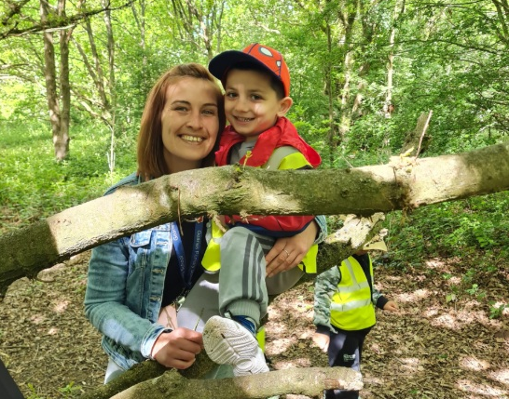

- Access to Outdoor and Adventurous Learning
Based on studies in London and the UK, there is a widely recognized decline in children's connection to nature, particularly in urban, socioeconomically disadvantaged areas like Redbridge. Research confirms this reduction impacts children's health, wellbeing, and educational outcomes, prompting various programs to re-engage young people with the natural world.
Our provision recognises and addresses the multiple interconnected factors contribute to the decline in children's connection to nature in London and Redbridge:
- Urbanisation and limited access to green space
- Socioeconomic deprivation:
- Increased screen time
- Reduced outdoor play and mobility
- Lack of teacher confidence and time
Our provision addresses the need to be actively implementing programs to reverse the trend of declining nature connection. Redbridge Council and its leisure trust, Vision RCL, run a nature conservation team that manages local open spaces and organises public events and school trips. Their Environmental Education program offers hands-on outdoor learning sessions at locations like Hainault Forest and Ray Park, however, staffing issues have caused interruptions to this programme.
In our work we focus on supporting teachers and practitioners from our school develop their confidence, skills and knowledge to run outdoor and adventurous learning experiences, centred on free play and nature connection. This work is delivered by professionally qualified nature therapists. the important role of nature, creativity and belonging in supporting children’s wellbeing and development.
Research has shown that children developing a reluctance to engage in The Outdoors are at greater risks of experiencing Increases in anxiety and depression at younger ages:
- Difficulties with emotional regulation and self-control
- Lack of socialization, sharing, and problem-solving skills
- Increased risk of obesity and Type II diabetes
- Vitamin D deficiency
- Higher stress levels
- Reduced creativity
- Lowered self-esteem
To reverse the cycle, research insists, education is essential. Children are especially impressionable and early exposure to nature in a safe environment, such as with a school, teacher or parent, could change their attitude. Creative solutions are necessary because as cities grow bigger and denser, accessing green space is becoming difficult for many, especially those in low-income communities (FSM) families of children with disabilities" and Ethnicity minority families.
Our Outdoor learning programmes include:
- “This is How We Walk in the Woods.”
- The Redbridge Fishing Lakes and Conservation Wellbeing Project.
- Outdoor adventurous learning.
- Forest and conservation experiences.
- Nature connection activities.
Outdoor provision supports:
- Emotional wellbeing.
- Communication.
- Confidence.
- Curiosity.
- Physical development.
- Self-regulation.
- Creativity.
- Environmental understanding.
- Physical and social health improvements
Practitioners receive specialist training to strengthen expertise in outdoor learning delivery.

- Equality and Belonging
The setting celebrates diversity, multilingualism and cultural identity. Projects such as “1000 Words of Belonging”, developed alongside artists, poets and community partners, support:
- Identity development.
- Self-esteem.
- Cultural inclusion.
- Multilingual communication.
- Creative expression.
- Family participation.
- Community belonging.
Children and families are encouraged to use home languages and share cultural experiences. The curriculum reflects diverse identities, inclusive representation and respect for difference. This work contributes significantly to children’s confidence, wellbeing and sense of identity.
The setting celebrates diversity, multilingualism and cultural identity. Key aspects of the “1000 Words for Belonging” project included:
- Multilingual Focus: The project investigates how different languages, dialects, and accents contribute to or hinder a sense of belonging in a school setting.
- The Podcast Series: Episodes, such as "The Language Body Map" and "The Power of Language," feature conversations about the "language body map" and the impact of lost languages.
- Creative Output: Alongside the podcast, the project has produced "100 Poems for Belonging," an anthology from young writers at Gearies Primary School.
- Partnerships: The initiative is supported by the School of Advanced Study, Arts Council England, and Longsight Theatre.
The “1000 Words of Belonging” working with Playwright Neela Doležalová and composer Richard Melkonian, poets Anthony Anaxagorou, Nina Mingya Powles, Talia Randall, Gabriel Akamo and Helen Bowell aims to understand the complicated emotions that arise in classrooms related to language and identity. This work contributes significantly to children’s confidence, wellbeing and sense of identity.

- Safeguarding, Accessibility and Transition
Safeguarding is central to all SEND practice. Leaders recognise that children with SEND may be more vulnerable to:
- Social isolation.
- Emotional distress.
- Exploitation.
- Poor mental health.
- Family stress.
- Barriers to accessing support.
All staff receive safeguarding training and understand the additional vulnerabilities associated with SEND. The setting works closely with families, social care, health professionals, Early Help services, mental health teams and community organisations to ensure children’s safety, wellbeing and dignity are prioritised at all times.

The setting is committed to accessibility for all children and families through:
- Adapted learning environments.
- Inclusive resources.
- Visual communication supports.
- Flexible approaches to participation.
- Support for multilingual families.
- Accessible family communication.
- Individual risk assessments where required.
Reasonable adjustments are made to ensure all children can participate fully in every aspect of nursery life.
Transitions are carefully planned and personalised. Support includes:
- Multi-agency transition meetings.
- Individual transition plans.
- Family visits and support.
- Information sharing.
- Visual transition resources.
- Emotional preparation.
- Collaboration with receiving settings.
Particular attention is given to children with SEND, communication needs and emotional vulnerabilities to ensure transitions are positive, confident and successful.
The SEND team work closely with the SENDCOs at with Secondary schools to ensure that transitions are smooth including inviting them to observe children at school and to attend Annual review meetings.
The school works with SENDATS transitional team to provide preparation for children when they are transitioning from one phase to another.

- Staff Development and Professional Expertise
Continuous professional development is a significant strength of the provision. Staff training includes:
- Speech and language development.
- ELKLAN Level 3.
- Trauma-informed practice.
- Emotional coaching.
- PACE approaches.
- SEND identification.
- Outdoor learning.
- Mental health and wellbeing.
- Neurodiversity.
- LEGO-based Therapy.
- Attachment-informed practice.
The “Permission to Play” programme provides protected professional learning time for staff to rehearse, reflect upon and embed evidence-informed approaches into daily practice.

Leaders prioritise reflective supervision and collaborative professional learning. As a result:
- Staff confidence is high.
- Practice is consistent.
- Provision is responsive.
- Interventions are implemented effectively.
- Children receive highly personalised support.
- Staff morale and teamwork are exceptionally strong.
Leaders also place significant emphasis on staff wellbeing and workload, contributing to a strong sense of professionalism and collective purpose across the provision.

- Measuring Impact
The impact of SEND provision is measured rigorously through:
- Developmental progress tracking.
- Attendance data.
- Communication and language outcomes.
- Emotional wellbeing outcomes.
- Family engagement.
- Child and parent voice.
- Professional evaluation.
- Comparative local and national data.
Evidence demonstrates:
- Significant improvement in communication and language outcomes.
- Increased attendance.
- Improved emotional wellbeing.
- Enhanced social interaction.
- Increased family confidence.
- Strong progress in personal, social and emotional development.
- Improved practitioner expertise.
- Effective early intervention.
Pupils demonstrate excellent behaviour and highly positive attitudes to learning. Relationships throughout the provision are warm, respectful and nurturing. Children develop confidence, resilience and independence through therapeutic approaches, outdoor learning, creative enrichment and highly inclusive experiences.
The standards achieved by pupils in reading, writing and mathematics significantly exceed national comparative outcomes. Pupils with SEND access ambitious curriculum content successfully because learning is carefully adapted and delivered with expertise.
Across the wider curriculum, pupils learn exceptionally well because learning is carefully sequenced, adapted and delivered with expertise.
Teachers continuously check pupils’ understanding through skilled questioning and responsive teaching. Misconceptions are identified quickly and addressed effectively. Pupils develop confidence in using subject-specific vocabulary and are encouraged to discuss learning collaboratively through paired and small-group work.
The needs of pupils with SEND are identified accurately and swiftly. Learning is carefully adapted to ensure all pupils can access ambitious curriculum content and experience success.
From Nursery onwards there is a sharp focus on developing communication and language. Children benefit from language-rich environments where they learn new vocabulary and develop confidence in expressing their needs, ideas and emotions.
Staff provide highly effective support for early reading and communication development. Regular assessment ensures that children requiring additional support receive timely intervention to help them catch up quickly.
The provision for personal development is exceptional. Children develop confidence, independence and resilience through a rich range of experiences, including outdoor learning, therapeutic interventions, creative arts projects and inclusive enrichment opportunities.
The school’s diverse community is celebrated and embraced. Pupils learn to respect one another’s backgrounds, experiences and identities. Projects supporting multilingualism, belonging and inclusion strengthen children’s sense of self-worth and community participation.
Leaders and governors are highly ambitious for all pupils and are determined to provide the very best experiences and outcomes for children and families. Staff receive high-quality professional development which strengthens expertise and supports exceptionally strong inclusive practice.
Leaders also place significant importance on staff wellbeing and workload. As a result, morale is high and there is a strong sense of teamwork, professionalism and collective purpose across the provision.
Leaders and governors remain highly ambitious for all pupils and are determined to provide exceptional experiences and outcomes for children and families.


- Areas for Development and Next Steps
Leaders demonstrate strong self-evaluation and a clear commitment to continuous improvement.
Key priorities include:
- Formalising entry and exit criteria for intervention groups.
- Embedding the Record of Concern (ROC) process consistently across the school.
- Further strengthening identification of SEND needs beyond Early Years.
- Continuing implementation of recommendations from OT, SALT and Educational Psychology reviews.
- Refining intervention tracking and impact evaluation.
- Continuing to strengthen parent and pupil voice.
- Ensuring the long-term sustainability of the Nursery Inclusion Programme for All (NIPA).
Leaders remain committed to sustaining improvement through reflective practice, partnership working and evidence-informed development.
- Conclusion
The provision represents a highly ambitious, compassionate and research-informed model of inclusive early years practice.
Over the last academic year, leaders have made significant strides in strengthening SEND provision, improving identification systems, broadening support and embedding inclusive practice throughout the curriculum and wider pastoral provision.
The substantial increases in SEND identification, EHCPs and improved outcomes demonstrate that pupils’ needs are being recognised earlier and supported more effectively. Strong multi-agency partnerships, exceptionally positive parental feedback and improved pupil outcomes further evidence the effectiveness of the school’s inclusive culture.
The Nursery Inclusion Programme for All (NIPA) maintains exceptionally high aspirations for every child. Leaders, practitioners and partners are united in the belief that:
- Every child can succeed.
- Every child deserves belonging.
- Early intervention changes lives.
- Inclusion is a right, not a privilege.
- Families must be empowered, not judged.
- Relationships are the foundation of learning.
The school continues to build a provision where every child, regardless of need, background or barrier, is known, valued, supported and empowered to achieve their full potential.

Contact Information
For further information regarding SEND provision, please contact:

- Co-Headteachers: Mrs A Dias and Mr D Lea
- Assistant Headteachers: Miss Fan (Assessment) and Mr R Khan (Inclusion)
- Designated Safeguarding Lead: Mrs A Dias
- Special Educational Needs Co-ordinator (SENCO): Mr R Khan
- Chairman of the Board of Governors: Dr A Ainley
- E-mail: admin@geariesprimaryschool.co.uk
- Telephone: 0208 550 1803

Families are encouraged to contact the setting at any stage to discuss concerns, support needs or additional provision.



