
  Gearies Primary School  Pupil premium strategy statement - 2026 | This statement details our school’s use of pupil premium (and recovery premium) funding to help improve the attainment of our disadvantaged pupils. It outlines our pupil premium strategy, how we intend to spend the funding in this academic year and outcomes for disadvantaged pupils last academic year.

Pupil premium strategy statement – Gearies Primary school
This statement details our school’s use of pupil premium (and recovery premium) funding to help improve the attainment of our disadvantaged pupils.
It outlines our pupil premium strategy, how we intend to spend the funding in this academic year and outcomes for disadvantaged pupils last academic year.

School overview
Detail | Data
Number of pupils in school | 890 (02/2026)
Proportion (%) of pupil premium eligible pupils | 11.5%
Academic year/years that our current pupil premium strategy plan covers (3-year plans are recommended) | 2024 – 2027  Current year: 2026
Date this statement was published | March 2026
Date on which it will be reviewed | February 2027
Statement authorised by | Dan Lea and Alex Dias - Co Headteacher
Pupil premium lead | Ray Khan - ASH
Governor | Lydia Kirby, lead for disadvantaged pupils

Funding overview
Detail | Amount
Pupil premium funding allocation this academic year | £149,380
Recovery premium funding allocation this academic year | /
Pupil premium (and recovery premium) funding carried forward from previous years | nil
Total budget for this academic year | £149,380

Part A: Pupil Premium Strategy Plan

Statement of intent
- Schools make a difference
- Actions must be, “Evidence informed” to ensure we have a sound understanding of the strength of evidence behind our planned provision
- Action focuses on embedding effective practices into all classroom practices
- All stakeholders must understand that disadvantaged children, and families, are not one homogenous group. While more likely to be less experienced in educational success, we must build on and raise all children’s experiences of success
- Implementation matters: Planning must focus on select priorities to give us the best chance of success
- There must be a shared understanding on the importance of this work and a shared ownership of the responsibility for building on the support our children receive.
- A comprehensive range of data analysis is used to inform this document, ensuring all intended actions are focussed on improvement priorities. Priorities which address the root causes of our children’s underachievement, where this exists. We have been brave enough to focus on data which challenges what we think, rather than support ideas and beliefs we have adopted.
- The focus of this planning is to slim down on the reporting and emphasis on year-by-year accountability and move towards a more important focus on longer term, sustainable strategies which enable children to achieve their full potential, this influences lifelong impacts. Leaders, teachers and practitioners must take ownership of the strategies and implementation of our planning.
- This is a working document, which will evolve in light of ongoing review. This may continue across a three-year period.
- This plan is focussed on actual improvement, not accountability. What we discover as effective practice will become policy so that practice and expectations are made sustainable.

Challenges
This details the key challenges to achievement that we have identified among our disadvantaged pupils.
Challenge number | Detail of challenge
- “The Invisible Dilemma” – Children living in bad housing conditions/at risk of evictions/homelessness | We know that poor conditions are more prevalent in private rented housing, with a greater proportion of homes being classed as non-decent compared to other tenures.  Private renting is the most insecure type of housing, with the continued existence of Section 21 ‘no fault’ eviction notices, which leaves many private renters under the constant threat of eviction. Private renting also remains the most unaffordable housing tenure, with private renters spending on average 40% of their income on rent. It is not uncommon for families who lose a private rented home to struggle to find another they can afford within their local area.  We believe we have at least There were 24 families living in temporary accommodation - worse than the average for London Borough’s.  For these children to have equal opportunity, to enjoy a long and healthy life, action is needed to ensure that they:  • are born into loving families with the means to adequately support them through childhood and that they enter school ready to learn;  • are encouraged to aim high and achieve the best they can in education; to attain the qualifications and skills that will equip them for later life  • gain good employment that pays enough to enable them to fully participate in their community  • have secure, affordable housing that adapts to their needs as they change through life  • live in places / communities that: make healthier choices the easy and obvious choice; minimise the risk posed by communicable disease and environmental threats to health; are safe and feel safe; offer support and encouragement throughout life but particularly in times of need, including periods of poor physical and mental health and later in old age  • have access to high quality health and social care services, appropriate and proportionate to their needs  Source: Barking & Dagenham, Havering and Redbridge Joint Strategic Needs Assessment Profiles: London Borough of Redbridge  2021
- Pupil Premium Children who also have Speech and Language difficulties and/or ASD, but families cannot access essential services or sources of support | The School’s Annual Statistical reviews evidence that many of our disadvantaged children also have a SEND need linked to Speech and Language or ASD  Our school is facing a significant pressure, which comes from supporting SEND children who do not have an EHCP but do have significant learning needs related to Speech, Language and Communication. In our school these accounts to 55.4 of identified SEND Types, compared to National figure of only 35.2. (Annual Statistical Review Report, 2023)  A Local Authority Review evidenced that 91% of children’s annual reviews needed amending, with this process predicted to take over 20 weeks for 50% of these children.  This work will focus on one of three principles:  – to meet the needs of the children and school community - selfishness - “To be driven by an Overwhelming commitment to serve the needs of all children.”
- Ensuring children have opportunity to achieve the Greater Depth Standard. | A review of last year’s work evidenced that this is an area for the school to review  Provide the time/space for professional development and support needed for teachers to understand the challenges we face and the need for them to adapt their provision in the face of internal and external imperatives
- To ensure our work on providing Early Intervention programmes becomes a sustainable part of our school’s provision | Families living in our borough experience higher levels of the following “risk factors” compared to other London borough’s: Child poverty (41%) Lower levels of affordable housing (past 3 years only 60 “affordable” homes built compared to 110/year across London) pay inequality (2.78) evictions (2.21) rough sleeping (330) families living on benefits (11.6%) unemployment (5.4%) The Institute of Education’s research indicates that children living in families facing two of these risk factors have worsening developmental outcomes, most notably in children’s language, speech and vocabulary development. With a 4.6-month gap in development now evident between disadvantaged children and their 3–5-year-old peers. The World Health Organisation has further identified that children facing such issues are at high risk of developing social and emotional issues, which in turn lead to an even greater negative impact on their long-term outcomes.  The Marmot Review clearly evidenced that good quality services focussed on Education and Care, in the early years, have enduring effects on health and life chances outcomes for both children and their families. This research is supported by similar work conducted by (amongst others) The Institute of Education, University of London, University of Oxford, University of Nottingham, The World Bank, The World Health Organisation and The Education Endowment Foundation. Research from a range of literature evidences that what we are trying to achieve through our NIPA Project will have the greatest levels of impact on improving the educational and health outcomes of our community, both children and parents. The World Bank’s research further evidences that interventions developed in this early year’s space are further proven to be the most valuable in terms of costs and resulting impacts. It is our intention to build a sustainable, inclusive provision which meets the needs of our community in innovative ways. To do this our work must focus on becoming an effective, “Supportive Partner” to both The North East London NHS Hub and The Redbridge CAMHS Partnership Group. This will involve proving that we can deliver projects that support the criteria identified in the NHS’s Long-Term Plan (2021)

Intended outcomes
This explains the outcomes we are aiming for by the end of our current strategy plan, and how we will measure whether they have been achieved.
Intended outcome | Success criteria
To provide Effective and Sustained Early Intervention Programmes for children and families who cannot access essential services to which they are entitled – “Justice as Fairness” - fair opportunity should be the most important motivation for our work | - To continue to provide sustainable Early Intervention for vulnerable children and families - in innovative ways to overcome recognised challenges in Local Authority essential services for families and children – SALT, EP, Children’s Centre access, early start initiatives. This will be achieved through our Nursery Inclusion Project for All – NIPA and our work with the Redbridge Educational Partnership Early Intervention Working party  - Build on the provision we offer for those not eligible for recognised status and support.  - Build on our partnerships with the Barking and Dagenham/ Havering and Redbridge CAMHS NHS Steering Groups to ensure sustained funding and support for our Early Intervention Programmes of work  - Build on our provision for children aged between 2 and 3 years – early start initiatives (Nursery Inclusion Project for All - NIPA)  - Building on the support for those families living in challenging home environments – shared sub-letting/households with more than one family living together in shared spaces, those in vulnerable renting situations/ at risk of homelessness  - Building on the support provided for our EAL children and our families who have recently arrived from abroad (RAFA)  - Build this work alongside partners in our school partnership group, within The Redbridge Education Partnership
To set high expectations for all children  To be courageous, honest and fair – built on our own intrinsic motivations to push ourselves to the limit –  “Greatness of Soul”- To understand we have made a serious, ethical vocational choice as teachers and need to develop within ourselves the capacity to take on these challenges without being vain or overwhelmed. | - Embedding effective strategies into all classroom practice - to ensure sustainable relationships, cultures and improvement.  - To support new leaders, develop improved balance between transactional and transformative leadership approaches to ensure all teachers are focussed on clearly communicated expectations (Reactional/Transactional) and have a personal awareness of their importance in these programmes (Proactive/Transformative) - (work of Boyatzis – “Instructional/ Transformational Leadership and when to use which)  - Provide the time/space for professional development and support needed for teachers to understand the challenges we face and the need for them to adapt their provision in the face of internal and external imperatives - to meet the needs of the children and school community - selflessness - “To be driven by an Overwhelming commitment to serve the needs of all children.”  - To use, “Guskey’s Impactful Model of CPD evaluation” within the evaluation of this strategy’s effectiveness – ensuring a wider range of stakeholders contribute to evaluation, therefore, creating a greater sense of ownership/accountability towards the strategy, this process will involve evaluations of:  - Teacher and Practitioners’ reaction  - Teacher and Practitioners’ learning  - Organisation and support  - Teacher and Practitioners’ use of new knowledge and skills  - Pupil learning outcomes  - Explore the robustness of our M6, UPS 1, 2 and 3 Teachers – To which extent do they have a sustained impact and reach beyond their own classrooms? To which extent do they show psychological ownership of this strategy? To what extent do they use their expertise to support others, through competence and clarity developing a more improved sense of control over outcomes and improvement?

Activity in this academic year
This details how we intend to spend our pupil premium (and recovery premium) funding this academic year to address the challenges listed above.

Teaching (for example, CPD, recruitment and retention)
Budgeted cost: £45,031
UPS Teacher Programme: Supporting our Upper Pay Scale Teachers by creating a professional development programme which centres on sustaining a strong sense of identity, self-efficacy and effectiveness
- Coaching elements of our programme: £24,998
- Lesson Study Elements of our programme: £10,187
- Support for teacher delivery: £9,846
Activity | Evidence that supports this approach | Challenge number(s) addressed
Explore the robustness of our M6, UPS 1, 2 and 3 Teachers impacts across the school:  To which extent do they have a sustained impact and reach beyond their own classrooms?  To which extent do they show psychological ownership of this strategy?  To what extent do they use their expertise to support others, through competence and clarity developing a more improved sense of control over outcomes and improvement? | Education Endowment Foundation Education Evidence Reviews:  - Socioeconomic disadvantage and the attainment gap  - Implementation in education  - Characteristics of effective teacher professional development  - An evaluation of our work conducted between 2021 and 2023  - A review of The Final report of The Ethical leadership commission (2019)  - A review of “Challenging the Orthodoxy of Effective School Leadership” – (Day, C Et al 1999)  - Professional development Learning led by Marc Rowland | 1,2,3
Pre improvement:  Review impacts of our UPS 1 and 2 Teachers on the outcomes of our PP/PP+ children – 16 teachers  Identify either:  - The positive impacts they are having on the children – sustained and beyond own classroom  - A need to improve impacts on outcomes in specific areas, such as writing progress and attainment | Education Endowment Foundation Education Evidence Reviews:  - Socioeconomic disadvantage and the attainment gap  - Implementation in education  - Characteristics of effective teacher professional development  - An evaluation of our work conducted between 2021 and 2023  - A review of The Final report of The Ethical leadership commission (2019)  - A review of “Challenging the Orthodoxy of Effective School Leadership” – (Day, C Et al 1999)  - Professional development Learning led by Marc Rowland | 1,2,3
Innovative Improvement:  Dependent upon pre improvement evaluation outcomes here the work focusses on either:  1. Supporting these teachers to share best practice  2. Supporting these teachers improve their practice  Innovative improvement demands teachers develop greater levels of psychological ownership of this strategy, regardless of which focus  Provide the time/space for professional development and support needed for teachers to understand the challenges we face and the need for them to adapt their provision in the face of internal and external imperatives - to meet the needs of the children and school community  This work will be achieved through a peer to peer Facilitated Action research approach | Education Endowment Foundation Education Evidence Reviews:  - Socioeconomic disadvantage and the attainment gap  - Implementation in education  - Characteristics of effective teacher professional development  - An evaluation of our work conducted between 2021 and 2023  - A review of The Final report of The Ethical leadership commission (2019)  - A review of “Challenging the Orthodoxy of Effective School Leadership” – (Day, C Et al 1999)  - Professional development Learning led by Marc Rowland | 1,2,3
Sustained improvement:  Case studies from the peer to peer Facilitated Action research approach will be used to support evaluation and share effective practice  “Guskey’s Impactful Model of CPD evaluation” will be used to evaluate the impact of this work.  Within the evaluation of this strategy’s effectiveness – ensuring a wider range of stakeholders contribute to evaluation, therefore, creating a greater sense of ownership/accountability towards the strategy, this process will involve evaluations of:  - Teacher and Practitioners’ reaction  - Teacher and Practitioners’ learning  - Organisation and support  - Teacher and Practitioners’ use of new knowledge and skills  - Pupil learning outcomes | Education Endowment Foundation Education Evidence Reviews:  - Socioeconomic disadvantage and the attainment gap  - Implementation in education  - Characteristics of effective teacher professional development  - An evaluation of our work conducted between 2021 and 2023  - A review of The Final report of The Ethical leadership commission (2019)  - A review of “Challenging the Orthodoxy of Effective School Leadership” – (Day, C Et al 1999)  - Professional development Learning led by Marc Rowland | 1,2,3

Targeted academic support (for example, tutoring, one-to-one support structured interventions)
Budgeted cost: £77,817
Evidenced based work
- To ensure our use of Accelerated Reader and MYon leads to measurable reading gains for boys, goals should move from habit formation (short term) to skill mastery (medium term) and finally to a culture of literacy (long term).
- To impact upon the outcomes for our disadvantaged children (notably boys) at the end of KS2 Mathematics – as evidenced by improvement in the GDS Scale Score Indicator data.
Budgeted costs cover:
- Lesson study cycles between UPS Teachers (14)
- Increased levels of moderation and progress reviews between Teachers and Leaders
- Small group/One-to-one tuition
- Employing staff to run specialized interventions
- CPD funding: National Professional Qualifications (NPQs) in EY and Mathematics, to improve classroom pedagogy.
- Cover costs: Providing cover time for teachers to engage in coaching, mentoring, lesson Study or training, allowing them to improve their skills.

Activity | Evidence that supports this approach | Challenge number(s) addressed
Targeted Academic Support for Pupil Premium children moving through Key Stage One and Two  - Contextual grid – mapping Pupil Premium Children and their needs across Year 1 to Year 6  - Ensuring Individual GROW Models align to identified needs for each child.  - Increased levels of moderation and progress review between teachers and Leaders | School Annual Statiscal Review 2025/2026  Education Endowment Foundation Education Evidence Reviews:  - Socioeconomic disadvantage and the attainment gap  - Implementation in education  - Characteristics of effective teacher professional development  - An evaluation of our work conducted between 2021 and 2024  - A review of The Final report of The Ethical leadership commission (2019)  - A review of “Challenging the Orthodoxy of Effective School Leadership” – (Day, C Et al 1999)  - Professional development Learning led by Marc Rowland | 1,2,3
Pre improvement:  A review of summative data evidenced that this is a key year group which needs additional, targeted academic support  (Data source: Sonar) | Education Endowment Foundation Education Evidence Reviews:  - Socioeconomic disadvantage and the attainment gap  - Implementation in education  - Characteristics of effective teacher professional development  - An evaluation of our work conducted between 2021 and 2024  - A review of The Final report of The Ethical leadership commission (2019)  - A review of “Challenging the Orthodoxy of Effective School Leadership” – (Day, C Et al 1999)  - Professional development Learning led by Marc Rowland | 1,2,3
Innovative Improvement:  The delivery of Targeted interventions in all core subjects which include all PP/PP+ children | Education Endowment Foundation Education Evidence Reviews:  - Socioeconomic disadvantage and the attainment gap  - Implementation in education  - Characteristics of effective teacher professional development  - An evaluation of our work conducted between 2021 and 2024  - A review of The Final report of The Ethical leadership commission (2019)  - A review of “Challenging the Orthodoxy of Effective School Leadership” – (Day, C Et al 1999)  - Professional development Learning led by Marc Rowland | 1,2,3
Sustained Improvement Phase  This work links into the action plan detailed in Strand One:  Explore the robustness of our UPS 1 and 2 Teachers:  To which extent do they have a sustained impact and reach beyond their own classrooms?  To which extent do they show psychological ownership of this strategy?  To what extent do they use their expertise to support others, through competence and clarity developing a more improved sense of control over outcomes and improvement? | Education Endowment Foundation Education Evidence Reviews:  - Socioeconomic disadvantage and the attainment gap  - Implementation in education  - Characteristics of effective teacher professional development  - An evaluation of our work conducted between 2021 and 2024  - A review of The Final report of The Ethical leadership commission (2019)  - A review of “Challenging the Orthodoxy of Effective School Leadership” – (Day, C Et al 1999)  - Professional development Learning led by Marc Rowland | 1,2,3

Wider strategies (for example, related to attendance, behaviour, wellbeing)
Budgeted cost: £26,532
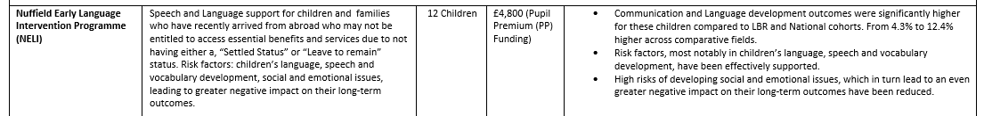

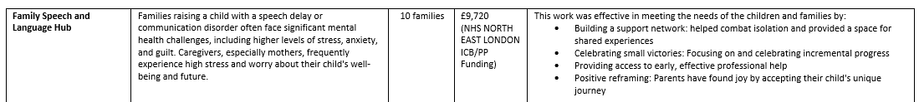

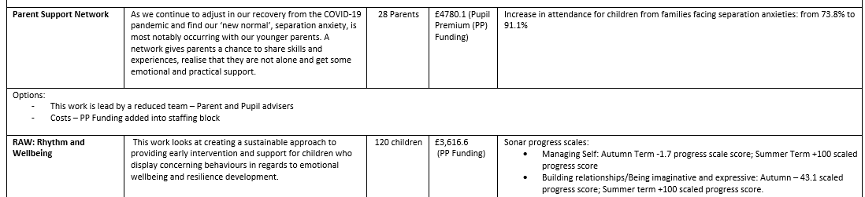

Activity | Evidence that supports this approach | Challenge number(s) addressed
To provide sustainable Early Intervention for vulnerable children and families | Education Endowment Foundation Education Evidence Reviews:  - Socioeconomic disadvantage and the attainment gap  - Implementation in education  - Characteristics of effective teacher professional development  - An evaluation of our work conducted between 2021 and 2024  - A review of The Final report of The Ethical leadership commission (2019)  - A review of “Challenging the Orthodoxy of Effective School Leadership” – (Day, C Et al 1999)  - Professional development Learning led by Marc Rowland  - The Marmot Review, 2010  - This work is supported by similar work conducted by (amongst others) The Institute of Education, University of London, University of Oxford, University of Nottingham, The World Bank, The World Health Organisation  - NHS’s Long-Term Plan (2021) | 4
Pre improvement:  Over the past 4 years we have developed our Nursery Inclusion Project for All (NIPA) provision.  We have begun designing and delivering innovative ways to overcome recognised challenges in Local Authority essential services for families and children – SALT, EP, Children’s Centre access, early start initiatives.  Our work now must focus on working with the Redbridge Educational Partnership Early Intervention Working party and The Barking and Dagenham/ Havering and Redbridge CAMHS NHS Steering Groups to ensure sustained funding and support for our Early Intervention Programmes of work | Education Endowment Foundation Education Evidence Reviews:  - Socioeconomic disadvantage and the attainment gap  - Implementation in education  - Characteristics of effective teacher professional development  - An evaluation of our work conducted between 2021 and 2024  - A review of The Final report of The Ethical leadership commission (2019)  - A review of “Challenging the Orthodoxy of Effective School Leadership” – (Day, C Et al 1999)  - Professional development Learning led by Marc Rowland  - The Marmot Review, 2010  - This work is supported by similar work conducted by (amongst others) The Institute of Education, University of London, University of Oxford, University of Nottingham, The World Bank, The World Health Organisation  - NHS’s Long-Term Plan (2021) | 4
Active Improvement Phase:  Working with our range of partners to ensure sustained funding and support for our Early Intervention Programmes of work | Education Endowment Foundation Education Evidence Reviews:  - Socioeconomic disadvantage and the attainment gap  - Implementation in education  - Characteristics of effective teacher professional development  - An evaluation of our work conducted between 2021 and 2024  - A review of The Final report of The Ethical leadership commission (2019)  - A review of “Challenging the Orthodoxy of Effective School Leadership” – (Day, C Et al 1999)  - Professional development Learning led by Marc Rowland  - The Marmot Review, 2010  - This work is supported by similar work conducted by (amongst others) The Institute of Education, University of London, University of Oxford, University of Nottingham, The World Bank, The World Health Organisation  - NHS’s Long-Term Plan (2021) | 4
Sustained Improvement Phase:  NIPA Provision has been effectively evaluated and designed in a way which ensures future sustainability for the programmes delivered through this provision | Education Endowment Foundation Education Evidence Reviews:  - Socioeconomic disadvantage and the attainment gap  - Implementation in education  - Characteristics of effective teacher professional development  - An evaluation of our work conducted between 2021 and 2024  - A review of The Final report of The Ethical leadership commission (2019)  - A review of “Challenging the Orthodoxy of Effective School Leadership” – (Day, C Et al 1999)  - Professional development Learning led by Marc Rowland  - The Marmot Review, 2010  - This work is supported by similar work conducted by (amongst others) The Institute of Education, University of London, University of Oxford, University of Nottingham, The World Bank, The World Health Organisation  - NHS’s Long-Term Plan (2021) | 4

Total budgeted cost: £149,380



Part B: Review of the previous academic year
Impacts of this work on children’s attainment (2025- 26)

Early Years
Outcomes were outstanding across all areas of tracked indicators (see table below)
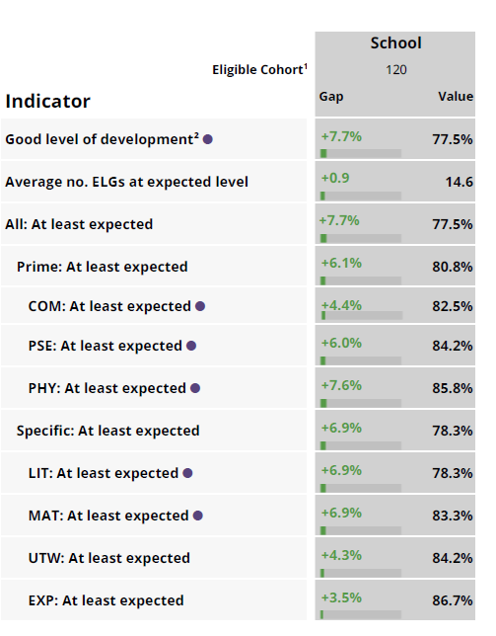

Key Stage Two
Outcomes were outstanding across all areas of tracked indicators (see tables below)

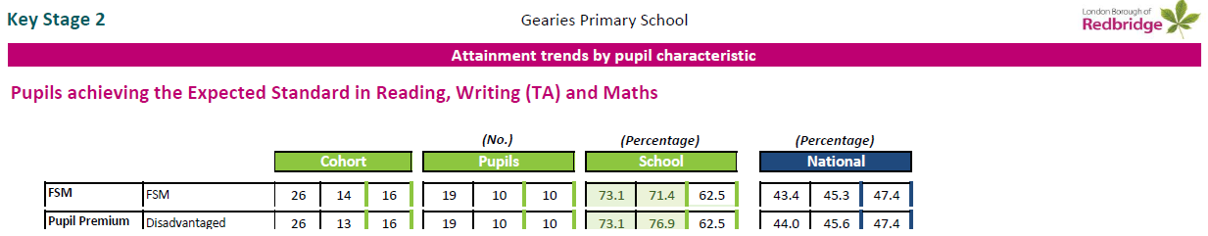

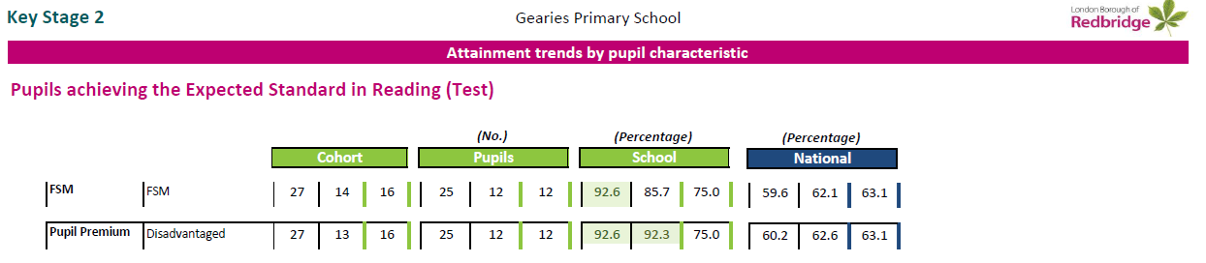
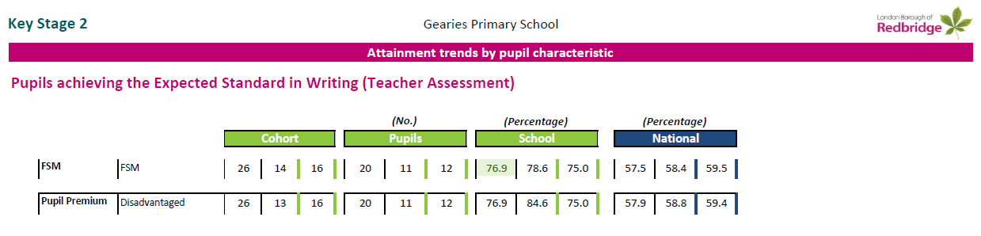

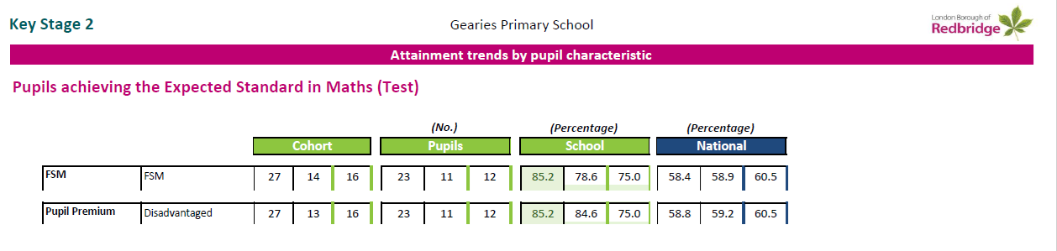

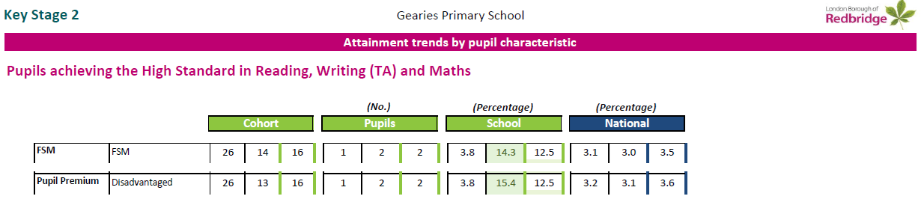

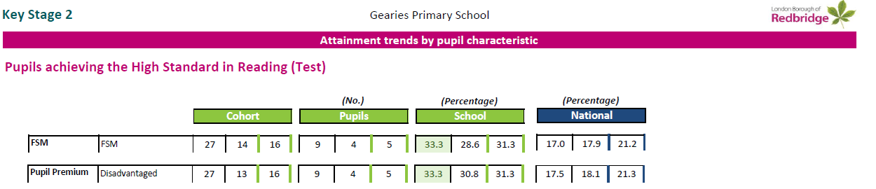

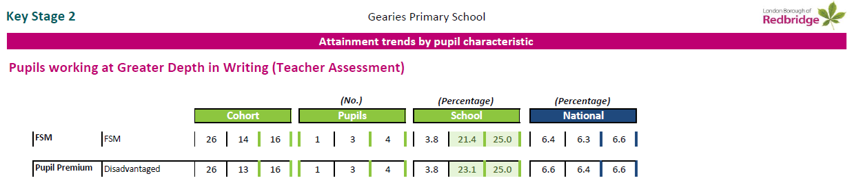

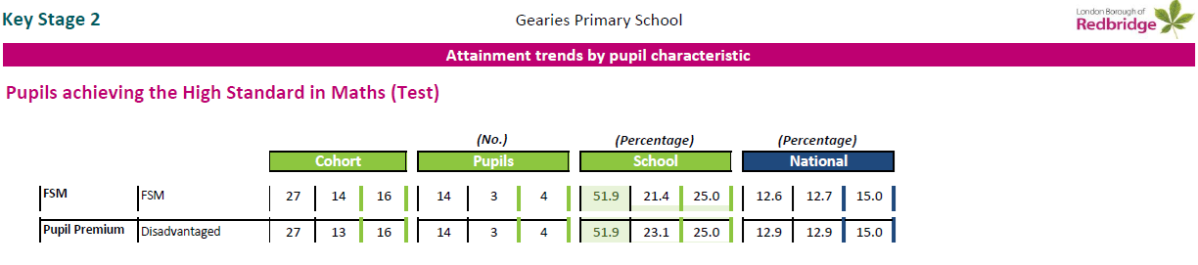

End of Key Stage Two Gap Analysis
Outcomes were outstanding across most areas of tracked indicators (see tables below)
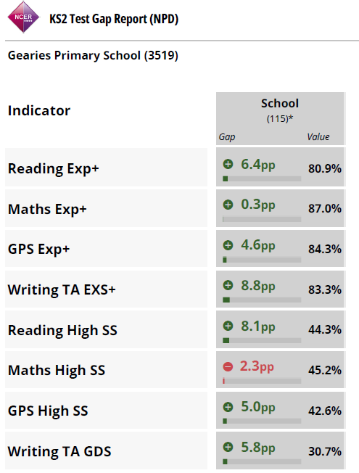

Prioritised Areas of focus for 2026- 27
These focuses were decided upon after the researching of the following evidence reviews:
- Education Endowment Foundation Education Evidence Reviews:
- Socioeconomic disadvantage and the attainment gap
- Implementation in education
- Characteristics of effective teacher professional development
- An evaluation of our work conducted between 2021 and 2023
- A review of The Final report of The Ethical leadership commission (2019)
- A review of “Challenging the Orthodoxy of Effective School Leadership” – (Day, C Et al 1999)
- Professional development Learning led by Marc Rowland
The Marmot Review, 2010
This work is supported by similar work conducted by (amongst others) The Institute of Education, University of London, University of Oxford, University of Nottingham, The World Bank, The World Health Organisation
NHS’s Long-Term Plan (2021)
- Barking & Dagenham, Havering and Redbridge Joint Strategic Needs Assessment Profiles: London Borough of Redbridge, 2021

Essential focus identified through this review:
- Early Years Provision – earlier identification
Our PP/FSM children with SEND Support performance compared to national figures evidence how our children achieve an average of 12.5 ELG’s to 12.2, a significant plus. This evidences the success of our Early Intervention Programmes (NIPA). However, our own analysis has identified an area of improvement – the outcomes for Pupil Premium children not identified as disadvantaged in our Early Years (later in KS1 or 2) who are therefore missing the earliest point of intervention and support.
We must focus on improving our early identification of PP/FSM and disadvantaged families to ensure all disadvantaged families receive high quality early support.
- Improving the attendance of our disadvantaged children
Attendance of Disadvantaged pupils is 91.56% as opposed to 95.2%, an area for development
- Improving the outcomes for our disadvantaged children in the end of KS2 Mathematics SATS – as evidenced by the GDS Scale Score Indicator data
We have seen a notable upwards trends for Boys, SEND Support, EAL, Indian children in this area; 25% of our Pupil premium achieved a Scaled Score evidencing Greater Dept Standard, this is significantly higher than the National average of 15%. In this area our annual statical review evidences 9 areas of outstanding outcomes compared to 8 in 2024, but a – 2.3 gap occurred this year, this needs investigation and enquiry.

- Create parent conferences (extended parent meetings)
Our work with both NIPA and PINS evidenced how this work was effective in meeting the needs of the children and families:
- Building a support network: Connecting with other parents in similar situations through support groups, helped combat isolation and provided a space for shared experiences.
- Celebrating small victories: Focusing on and celebrating incremental progress, no matter how small, helped to shift the family's focus from frustration to proactive support and acceptance.

- Early, effective professional help: Access to timely and integrated speech and language therapy, along with specialized and adapted mental health services, proved vital in improving outcomes for both the child and the family.
- Positive reframing: Parents have found joy by accepting their child's unique journey, focusing on their child's strengths, and appreciating the small moments of progress rather than adhering to rigid expectations.

This work was predominantly developed across EYFS and KS1 phases, we need to look at the professional learning here and how this work can be shared across KS2

- Continue to develop our capacity and sustainability in effectively meeting the needs of disadvantaged children with SEND needs.

- 12% of disadvantaged have an EHC opposed to 4% of non-disadvantaged.
- 31% of disadvantage children have a SEND need as opposed to 17% non-disadvantaged.

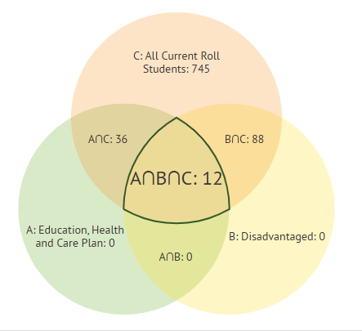
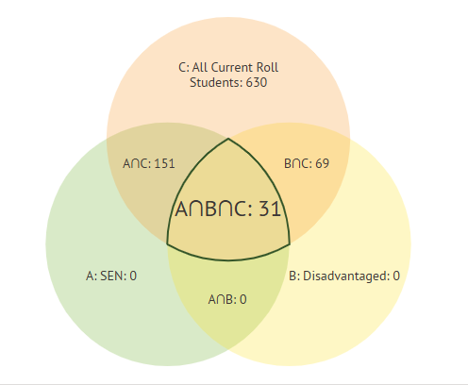

- Redesigning an intervention space for Key Stage 2 (KS2) children with Special Educational Needs and Disabilities (SEND) to enable the improvement of Interventions.
- Developing classrooms to improve enhanced communication and classroom experience for SEND pupils.

Outcomes for disadvantaged pupils
- Outcomes for disadvantaged children at Gearies Primary School are significantly higher when compared to National achievements.
- These outcomes have been sustained over the latest three-year trend – These standards have been maintained from the opening of the Primary school in 2013
- The school received a letter of recognition from Bridget Phillipson as the outcomes Gearies Primary School achieved at the end of the 2024/25 academic year places our schools’ achievements among the very best nationally, and this is a significant achievement.
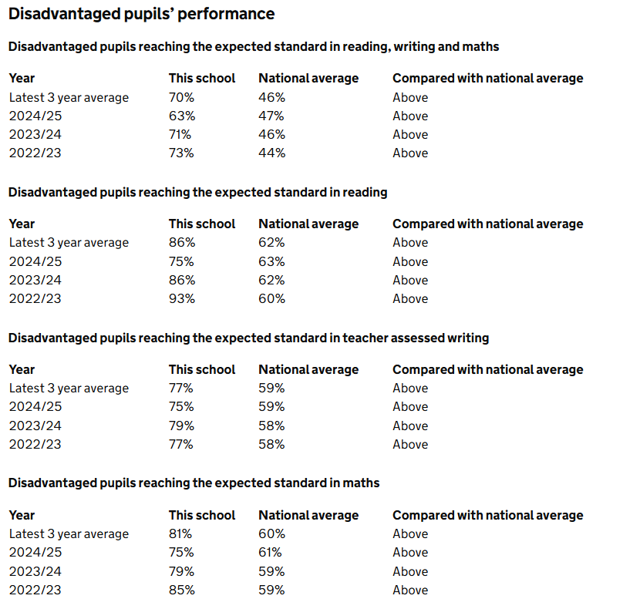

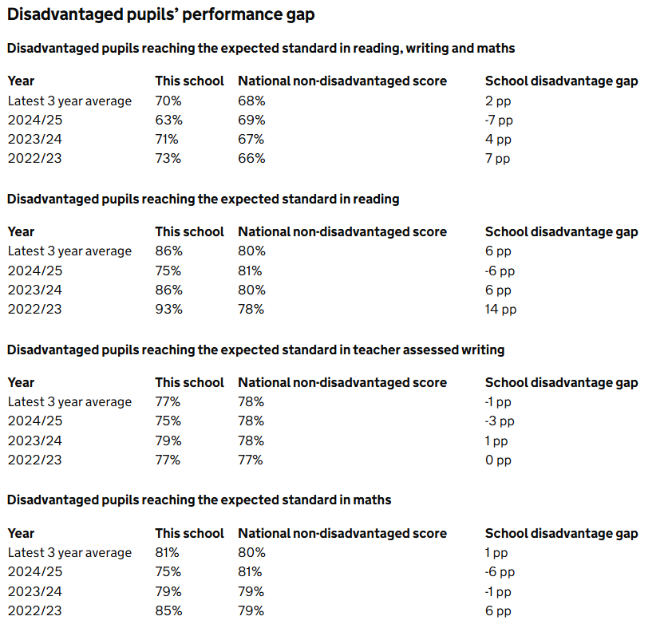

Outcomes for our disadvantaged parents and families
- Building a support network: Connecting with other parents in similar situations through support groups, helped combat isolation and provided a space for shared experiences.
- Celebrating small victories: Focusing on and celebrating incremental progress, no matter how small, helped to shift the family's focus from frustration to proactive support and acceptance.
- Early, effective professional help: Access to timely and integrated speech and language therapy, along with specialized and adapted mental health services, proved vital in improving outcomes for both the child and the family.
- Positive reframing: Parents have found joy by accepting their child's unique journey, focusing on their child's strengths, and appreciating the small moments of progress rather than adhering to rigid expectations.
Impacts of this work on our school’s improvement and culture

Three case studies have been included in this review to evidence impacts of improvement in school culture.
- Community Wellbeing: Stay and Play sessions and Family Networks
- Our Speech and Language Family Hub
- Our implement of curriculum change that created a more cohesive and responsive pedagogy of teaching by combining our Reading and Writing lessons.

The Marmot Review clearly evidenced that good quality services focussed on Education and Care, have enduring effects on health and life chances outcomes for both children and their families.
Our plan looks to challenge a worrying, emerging narrative. This narrative focuses on the “disadvantagement” and learning deficit of our most vulnerable children and families compared to others. This narrative does not acknowledge the many wonderful abilities, skills and contributions our vulnerable families bring into our vibrant community. Nor does it focus on the fact that this learning deficit is a result of inaccessible services that a family should, by rights, be entitled to.
The narrative focuses on the child, the family’s poverty and lack of English as significant factors for learning deficit, not a school’s or communities focus on a commitment to better meeting their needs.
Our strategic planning ensures that rather than focus on this damaging narrative, we will focus our work on the narrative of capacity building. How we bring together our community, families and professionals, to build a provision dedicated to both outstanding education and health care.
The Marmot Review clearly evidenced that good quality services focussed on Education and Care have enduring effects on health and life chances outcomes for both children and their families. This research is supported by similar work conducted by (amongst others) The Institute of Education, University of London, University of Oxford, University of Nottingham, The World Bank, The World Health Organisation and The Education Endowment Foundation.
Research from a range of literature evidences that what we are trying to achieve through our plan will have the greatest levels of impact on improving the educational and health outcomes of our community, both children and parents. The World Bank’s research further evidences that interventions developed in this early intervention space are further proven to be the most valuable in terms of costs and resulting impacts.



