Accessibility Plan

Approved by | The Governing Body
Last Reviewed | May 2026
Next Review date | May 2027

 | GEARIES PRIMARY SCHOOL  We act in the best ways we can; to support each child become the best version of themselves

Contents

- Introduction
- School Context and Strategic Considerations
- Vision and Aims
- Accessibility Plan
4.1 Physical Environment
4.2 Curriculum Access
4.3 Information Delivery
- Specialist Accessibility
5.1 Mobility Disabilities (Pupils and Adults)
5.2 Visual Impairment
- Staffing Capacity and Impact on Accessibility
- Admissions and Equality of Access
- Monitoring, Evaluation and Governance
- Linked Policies
- Conclusion

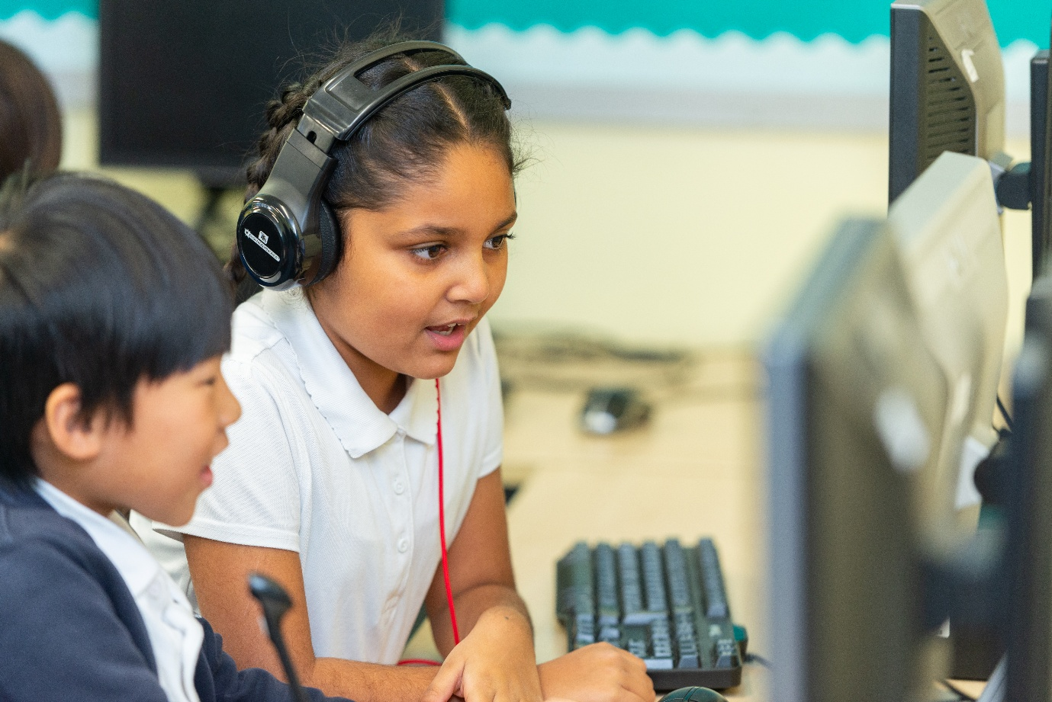

Gearies Primary School Accessibility Plan

1. Introduction
This Accessibility Plan is written in accordance with the Equality Act 2010 and Department for Education guidance. It sets out how Gearies Primary School will:
- Increase access to the curriculum for disabled pupils
- Improve the physical environment of the school
- Enhance the accessibility of information for all stakeholders
The plan reflects the school’s inclusive ethos and commitment to ensuring that pupils, staff, parents, and visitors—regardless of need, including mobility impairments—can participate fully, safely, and with dignity in all aspects of school life.
It recognises the significant contextual challenges of operating beyond capacity and demonstrates how the school continues to meet statutory duties while maintaining high-quality provision.
Review cycle:
Annual review by Senior Leadership Team and Governing Body, with termly monitoring of key actions.

2. School Context and Strategic Considerations
Gearies Primary School is a large, four-form entry primary school serving a highly diverse and complex community.

Key Characteristics
- Total pupils (projected 2026): 906 (capacity: 756)
- SEND: 21% (190 pupils)
- EHCPs: 5% (42 pupils)
- EAL: 93%
- Ethnic minority: 96%
The school operates significantly above its designed capacity, creating sustained pressure on:
- Physical space and safe movement
- Access to specialist provision
- Staffing deployment
- Ability to implement structural adaptations

Accessibility Challenges Due to Overcapacity
- Congested corridors and stairwells
- Limited space for mobility aids (wheelchairs, walkers)
- Restricted flexibility for room reconfiguration
- High demand on specialist spaces
- Multi-level buildings with limited lift access
- Narrow corridors in older buildings
- Full classroom occupancy
Despite these challenges, the school maintains a strong inclusive model, recognised as strong/outstanding practice (Ofsted 2024), through careful planning, staffing, and risk management.

3. Vision and Aims
Gearies Primary School is committed to:
- Providing equitable access to a broad and balanced curriculum
- Creating an inclusive, safe, and welcoming environment
- Removing barriers to learning and participation
- Promoting independence, dignity, and aspiration
- Maintaining high expectations for participation in all aspects of school life
- Supporting pupils, staff, parents, and visitors with disabilities
- Ensuring barrier-free access wherever reasonably possible
- Promoting safe and independent movement, particularly for those with mobility needs
- Making anticipatory reasonable adjustments rather than reactive ones
- Meeting and exceeding statutory expectations through proactive planning

4. Accessibility Plan

4.1 Physical Environment
Objective:
To improve access to the school site for pupils, staff, and visitors with disabilities, including those with mobility needs.

Current Provision
- Step-free access to key entrances
- Ramps and designated access routes
- Accessible toilet facilities
- Disabled parking spaces near entrances
- Clearly defined pathways and navigation routes
- Specialist SEND provision spaces
- Some adjustable furniture

Contextual Constraints
- 1920s buildings with limited adaptability
- Ongoing subsidence affecting classroom availability
- Full utilisation of all teaching spaces
- Over-capacity causing congestion
- Multi-level buildings with limited lift access
- Narrow corridors

Planned Improvements (2026–2029)
- Installation of additional handrails and grip supports
- High-contrast stair markings
- Improved signage (visual and tactile)
- Introduction of priority movement routes
- Timetabling adjustments to stagger movement
- Ongoing classroom layout reviews to:
- Ensure wheelchair turning space
- Provide accessible seating
- Procurement of height-adjustable desks and specialist seating
- Playground accessibility audit to:
  - Improve surfaces
  - Adapt equipment
  - Create safe zoning areas
- Maintenance of decluttered circulation routes
- Regular review of evacuation routes for accessibility

Individual Adjustments
- Personalised risk assessments and access plans
- Ground-floor classroom allocation where required
- Adult support during movement (while promoting independence)

Success Criteria
- Safe and confident movement for all users
- Reduced congestion-related risks
- All areas accessible or supported by reasonable adjustments
- Positive feedback from pupils, staff, visitors, and professionals

4.2 Curriculum Access
Objective:
To ensure all pupils, including those with disabilities and mobility needs, can access and achieve within the full curriculum.

Current Provision
- Adaptive teaching embedded across the school
- High levels of adult support (59.47 Teaching Assistants)
- Access to specialist services (SALT, therapy, SEND specialists)
- Targeted interventions and EHCP provision

Enhanced Provision for Mobility Needs
- Flexible classroom organisation for:
  - Easy resource access
  - Inclusive group work
- Adapted PE and outdoor learning
- Assistive equipment where appropriate
- Timetabling to reduce excessive movement
- Rest breaks where fatigue impacts learning

Planned Improvements
- Ongoing staff training in:
  - Inclusive pedagogy
  - Supporting physical disabilities
  - Promoting independence
- Increased use of assistive technology
- Expansion of inclusive extracurricular activities
- Strengthened EHCP and SEND Support Plan reviews
- Development of multi-sensory teaching approaches
- Increased use of adapted PE strategies and equipment
- Strengthening pupil voice in planning adaptations

Success Criteria
- Disabled pupils make strong progress
- Full participation in lessons and school life
- No reduction in curriculum entitlement due to physical barriers
- Provision remains responsive and evidence-informed

4.3 Information Delivery
Objective:
To ensure information is accessible to all pupils, parents, carers, and visitors.

Current Provision
- Verbal and written communication
- Visual supports in classrooms
- Digital communication systems

Planned Improvements
- Alternative formats (large print, Braille, audio)
- Accessible digital platforms
- Website compliance with accessibility standards
- Translation services for EAL families
- Remote access options for meetings

Mobility-Specific Considerations
- Minimising need for on-site attendance where barriers exist
- Ensuring accessible reception and meeting areas
- Providing seating and appropriate waiting arrangements

Success Criteria
- Independent access to information for all stakeholders
- Increased parental engagement
- Full participation for individuals with mobility needs

5. Specialist Accessibility

5.1 Mobility Disabilities (Pupils and Adults)
The school adopts a proactive, personalised approach.

Key Strategies
- Individual healthcare and access plans
- Liaison with:
  - Occupational therapists
  - Physiotherapists
  - Local authority services
- Safe storage and access for mobility aids
- Adapted timetables
- Adult support during high-risk times

Risk Management
- Personal Emergency Evacuation Plans (PEEPs)
- Staff training in manual handling
- Adjusted routines to avoid peak congestion

5.2 Visual Impairment
The school adopts an anticipatory and individualised approach.

Environment
- High-contrast markings
- Tactile signage
- Decluttered layouts
- Enhanced supervision

Curriculum
- Adapted materials (large print, Braille)
- Assistive technology
- Multi-sensory teaching
- Verbalisation of visual information

Information
- Accessible communication formats
- Screen-reader compatible resources

Specialist Support
- Input from Qualified Teachers of the Visually Impaired (QTVIs)
- Mobility and independence training

Risk Management
- Personalised evacuation plans
- Adjusted timetables
- Monitoring due to site congestion

6. Staffing Capacity and Impact on Accessibility
The school has invested significantly in staffing:
- 59.47 Teaching Assistants
- Specialist SEND and therapeutic staff
- Annual cost: approximately £1.4 million
This enables:
- Targeted interventions
- Strong support for EHCP pupils
- High-quality inclusive practice
However:
- Staffing is at maximum sustainable capacity
- Physical support needs are resource-intensive
- Class sizes remain high (30:1)
- Any increase in pupil numbers would reduce support and compromise accessibility

7. Admissions and Equality of Access
The school complies fully with statutory requirements and ensures disabled individuals are not treated less favourably through:
- Inclusive admissions procedures
- Early consultation with families
- Early planning for mobility needs
- Implementation of reasonable adjustments
- Liaison with external agencies

Capacity Considerations
Due to over-capacity, further admissions may:
- Exceed safe building capacity
- Limit reasonable adjustments
- Reduce access to specialist provision
- Compromise safe movement and evacuation
This would create prejudice to efficient education and safe accessibility.

8. Monitoring, Evaluation and Governance
The plan is:
- Reviewed annually
- Monitored termly
- Evaluated through:
- Progress data
- Participation
- Safety measures
- Stakeholder feedback
- Updated in response to need and legislation
The Governing Body ensures accountability for:
- Statutory compliance
- Impact of accessibility measures
- Alignment with DfE and Ofsted expectations

9. Linked Policies
- SEND Policy
- Equality Policy
- Health and Safety Policy
- Behaviour Policy
- Teaching and Learning Policy
- Supporting Pupils with Medical Needs Policy

10. Conclusion
Gearies Primary School demonstrates a strong commitment to accessibility through:
- Proactive and anticipatory planning
- Significant staffing investment
- Individualised support
- Effective use of space and resources
Despite operating significantly beyond capacity, the school continues to meet its statutory duties.
However, further expansion would:
- Compromise safe movement and accessibility
- Reduce access to provision
- Impact the quality of education
- Undermine inclusive practice

This plan evidences both strong compliance and the limits of sustainable provision, in line with Department for Education expectations and Ofsted priorities.

